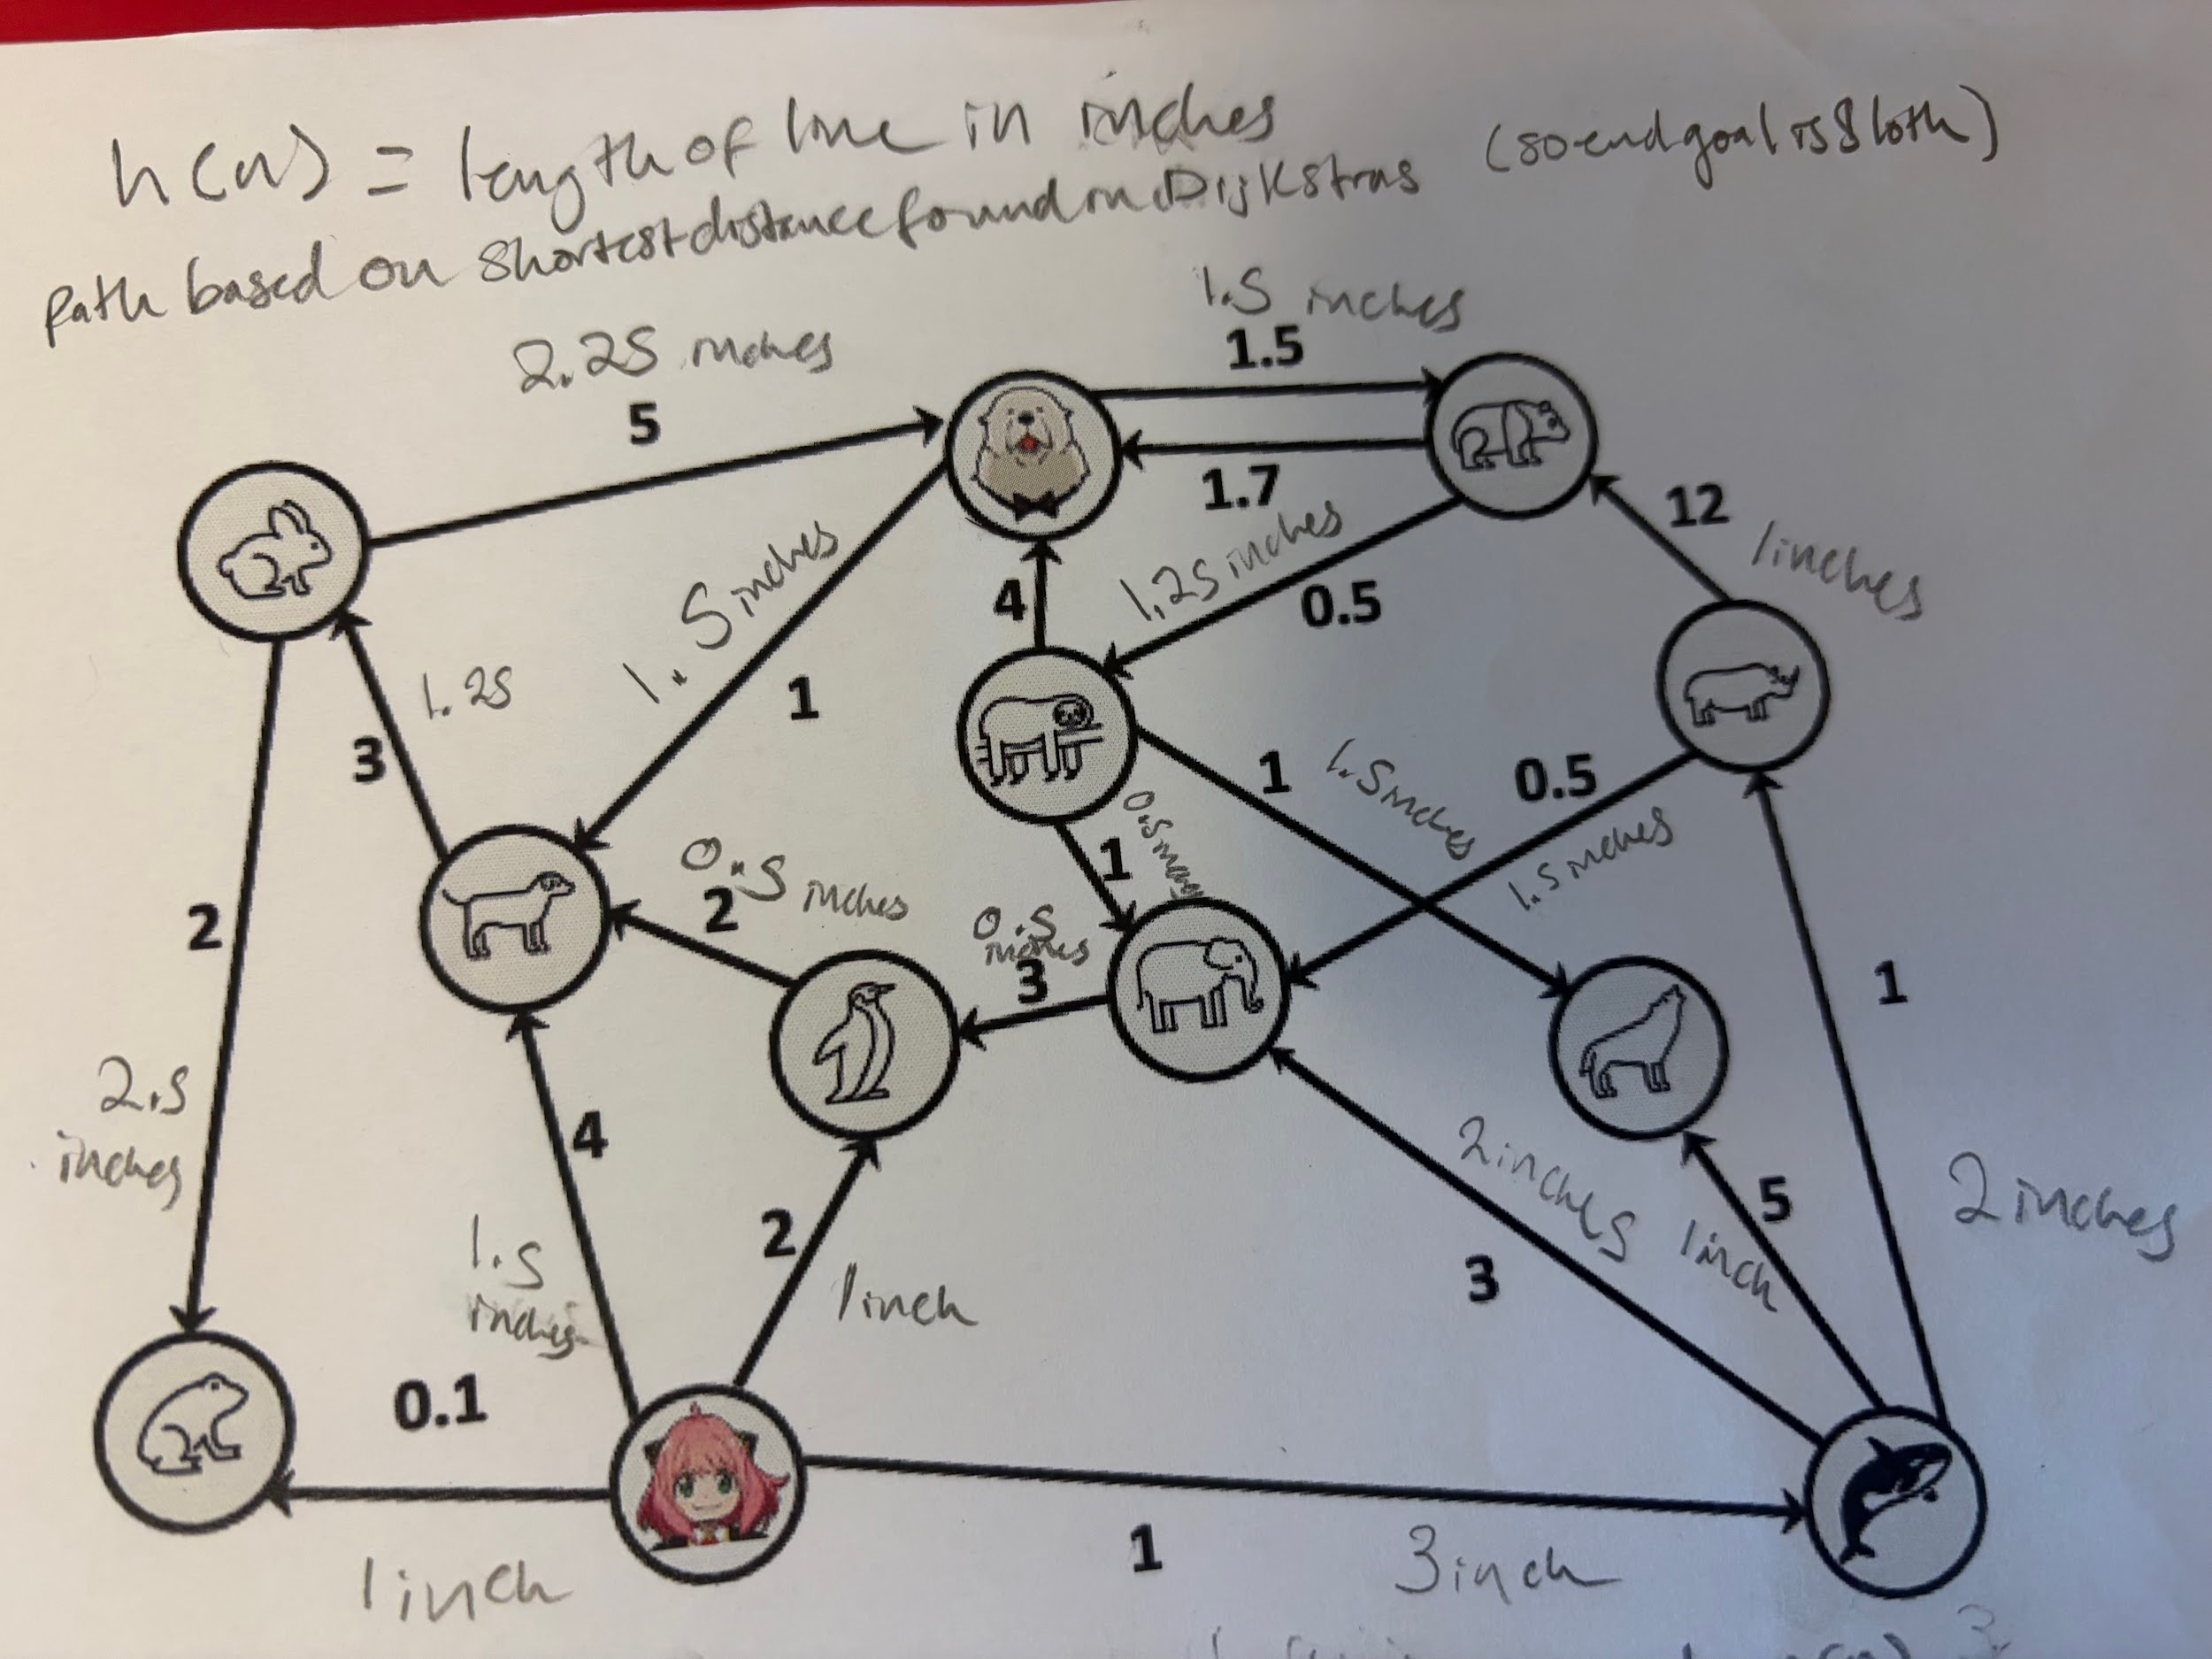

Node | (g(n)) | (h(n)) to Sloth | (f(n)=g+h)
Anya | 0 | 5 | 5
Frog | 0.1 | 6 | 6.1
Whale | 1 | 2.5 | 3.5
Penguin | 2 | 4.5 | 6.5
Rhino | 2 | 2 | 4
Elephant | 2.5 | 0.5 | 3
Dog | 4 | 4 | 8
Wolf | 6 | 1.5 | 7.5
Rabbit | 7 | 5 | 12
Bond | 12 | 2.75 | 14.75
Bear | 13.5 | 1.25 | 14.75

